

**USER MANUAL**

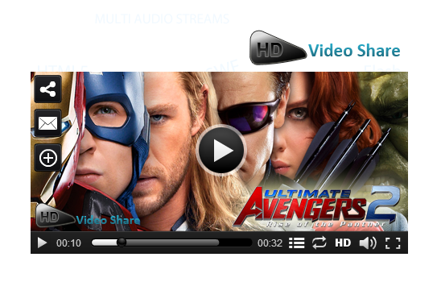

**Joomla HD Video Share**

Product Version : 3.4.1

Compatible : Joomla 1.5+

**Joomla HD Video Share**! Brings life to Joomla pages by allowing you to play popular video formats such as MP4, M4V, M4A, MOV, Mp4v,FLV and F4V in different browsers. With some salient features like HTML5 support to play videos in iPhones & iPads, RTMP streaming, Monetization, Native language support, and Social Bookmarking, the player promises to be ultimately unique.

**CONTENTS**

|  |  |
| --- | --- |
| **Preface** | 4 |
| * About This Document | 4 |
| * Updates, Comments, and Suggestions | 4 |
| * Disclaimer | 4 |
| **HD Video Share for Joomla** | 5 |
| * Introduction | 5 |
| * Minimum Requirements * List of HD Video Share files | 5  5 |
| **Installation Steps** | 6 |
| **Configure HD Video Share** | 9 |
| * Member Videos | 11 |
| * Member Details | 12 |
| * Admin Videos | 13 |
| * Category | 22 |
| * Player Settings | 23 |
| * Site Settings | 30 |
| * Google Adsense | 32 |
| * Video Ads | 32 |
| **Home Page Look** | 36 |
| * Client side settings | 37 |
| * My Videos | 39 |
| * Logout | 42 |
| **Contact Us** | 42 |

Preface

**About This Document**

This document provides information on how to download, install, configure and use HD Video Share for Joomla.

**Updates, Comments, and Suggestions**

Please forward your valuable comments, suggestions or questions about the information contained in this document to [assist@apptha.com](mailto:assist@apptha.com).

**Disclaimer**

Apptha reserves the right to add, remove, modify business models, processes related to Packaging, selling, marketing, developing extensions and themes of Apptha.com at any time and without prior notification. Apptha reserves the right to add new features to its products based on research and market needs. Apptha reserves the right to remove any feature of its products that does not fulfill expectations.

HD Video Share for Joomla

**Introduction**

The HD Video Share is a Joomla extension for videos sharing with built-in HD FLV Player. Users can add videos from local disk, YouTube and from any URLs. One big reason for the success of our extension is because of regular updates and features. HD Video Share always aims at top customer satisfaction. Though we don’t provide the source file of the player we are flexible enough in customizing the player based on the customer request at very low cost. We trust you will enjoy the process and can then look forward to tailoring HD Video Share to your own specific requirements.

Installing and using HD Video Share is generally straight forward, getting your perfect Web site takes a lot more effort but there is much, as you will discover, that has been done to make the process easier along the way. This component comes with few free modules. By using these free modules, you can change your Joomla website as video sharing website like YouTube and Vimeo.

**Minimum System Requirements**

* To successfully install and use HD Video Share you must have a fully operational Web server (Apache is the optimum) with Joomla! Installed.
* HD Video Share has been successfully tested on many variants within the main three OS for Windows, Linux, Apple Mac OSX with Joomla installed. It may well work on other platforms but this is less well documented.
* HD Video Share is also regularly used and tested through the main Web browsers available such as IE6+, Firefox 1.5 +, Safari, and Opera but it may also work with others.

**List of HD Video Share Files**

HD Video share package is available for Joomla 1.5,1.6,1.7, 2.5 and 3.x. Only logo and logo configuration are the major difference between free and paid package. Your free download includes the following modules:

1. Search Videos.

2. Featured Video.

3. Video Category.

4. Recent Videos.

5. Related Videos.

6. Popular Videos.

Installation Steps for Joomla 1.5

It is very easy to install the downloaded files.

* Log on to Joomla Administration page.
* Go to **Extensions -> Install/Uninstall ->** Choose file.
* Select the component downloaded and click **Upload File** and install.

Now the component will get installed successfully. In single installation you will get all the six modules and components.

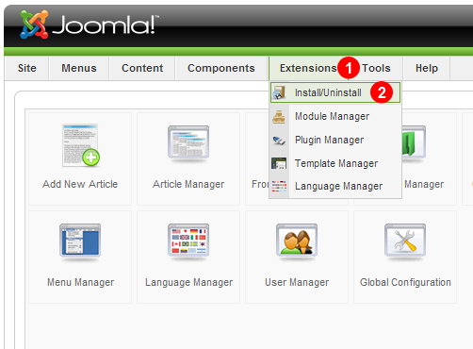

Installation Steps for Joomla 1.6, 1.7 and 2.5

1. Log on to Joomla Administration page.
2. **Extensions -> Extension Manager-->** Choose file.
3. Select the component downloaded and click **Upload File** and install.

Now the component will get installed successfully. In the single installation you will get all the six modules and components.

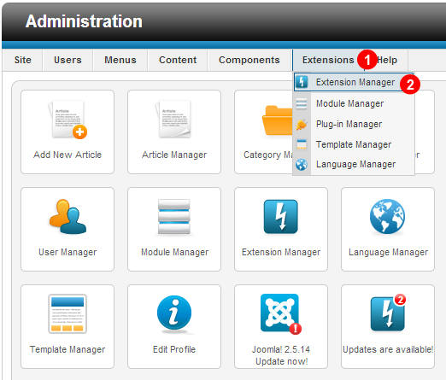

Installation Steps for Joomla 3.0

1. Log on to Joomla Administration page.
2. **Extensions -> Extension Manager-->** Choose file.
3. Select the component downloaded and click **Upload File** and install.

Now the component will get installed successfully. In the single installation you will get all the six modules and components.

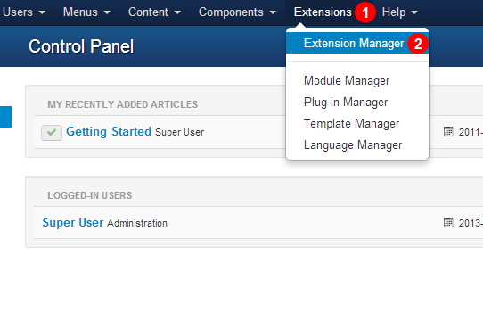

Configuring HD Video Share

**To assign component in Joomla 1.5:**

Log on to Joomla **Admin -> Menus -> Your_Menu_name** and select the menu where you want to assign the component, Click **Change Type -> Select HD Video Share** from the list -> Click **Index** (Default Layout) -> **Name the Menu ->Save.**

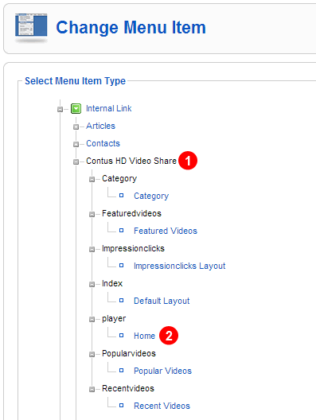

**To assign component in Joomla 3.0:**

To assign this component in a menu, Log on to Joomla **Admin -> Menus -> Your_Menu_name**. Here select the menu item where you want to assign the component, Click **"select" -> Select "Home"** under Contus HD Video Share from the popup.

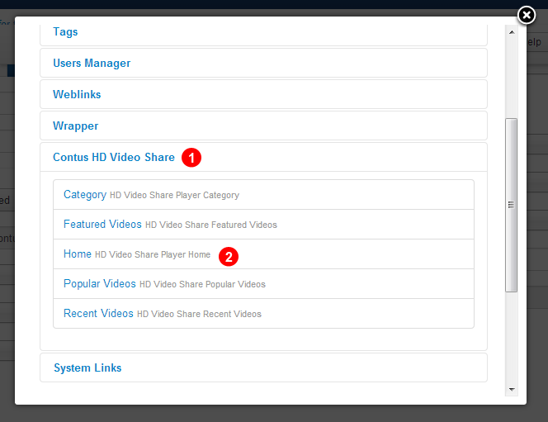

Apart from installation and assigning the component to the menus, remaining all the steps is same in Joomla ***1.5, Joomla 1.6, 1.7, 2.5, and 3.0+***

**Member Videos**

This is the primary tab: it lists all the videos added by the users from the front end. On this page you can do the following.

1. You can sort the videos by dragging on it.

2. You can modify the comments under comment column.

3. The corresponding streamer name, streamer path, videos link, thumbnail link for that member added will be display under the responding columns.

4. Also can view the postroll ads, preroll ads, midroll ads videos.

5. You can search/Filter videos of any user

6. You can view Ratings and Number of views of any video.

7. You can view/delete videos of any particular user.

8. You can either choose publish or un-publish any videos added by users

9. You can either choose enable featured or disable featured. It has been included in the features videos list.

**Joomla 1.5:**

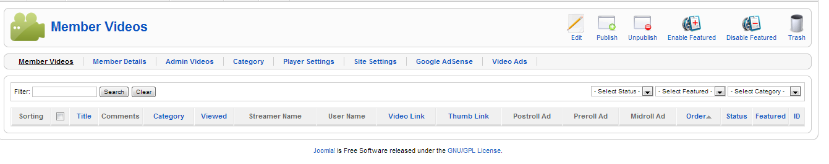

**Joomla 2.5:**

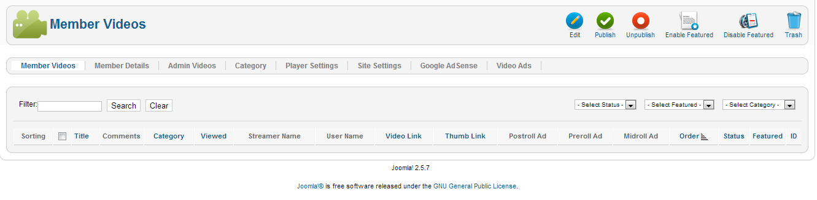

**Joomla 3.0:**

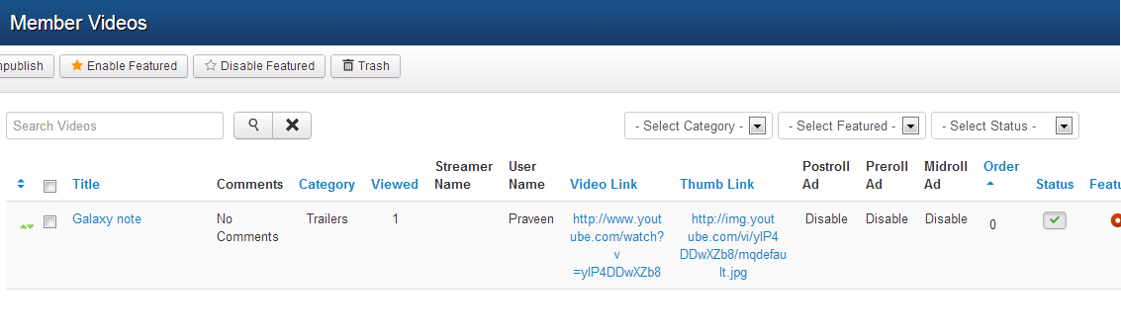

**Member Details**

In this section, admin can view all the details of the sign-up users and can control them by active or de-active.

**Joomla 1.5:**

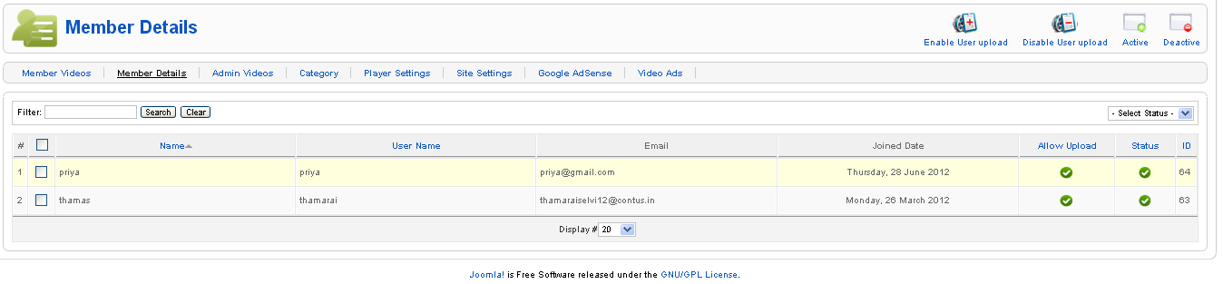

**Joomla 1.6:**

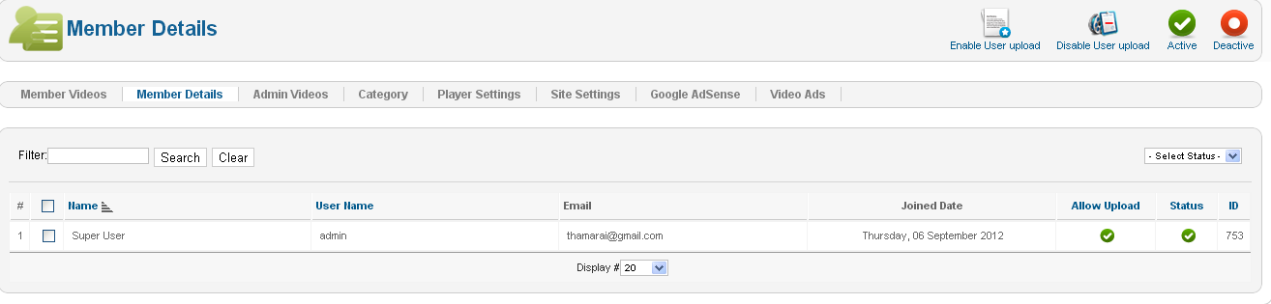

**Joomla 3.0:**

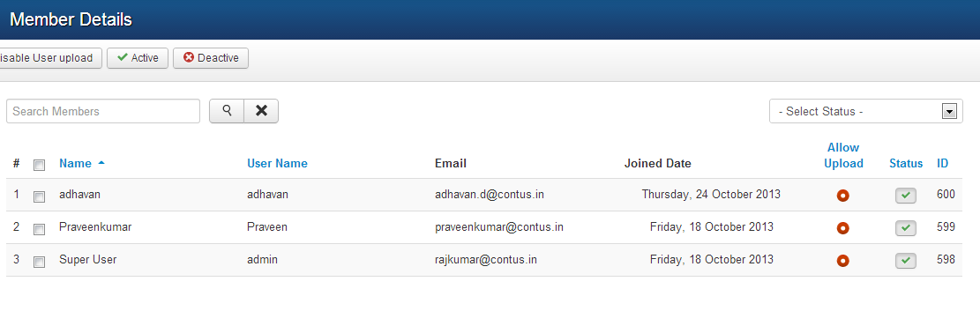

**Admin Videos**

* This is the place where admin can add videos to HD Video Share categories. HD Video Share accepts both streaming and normal way of playing videos. By default it is set to None where you can add videos through following methods Upload, Direct URL, YouTube URL and FFMPEG.
  + After adding the videos via any below methods, kindly update the video info section where you can add Title,Description, Target URL for the video, assign Category, sort order(recently we added Ajax sorting where you can sort the videos simply by Click and drag from the Videos tab), enable post roll and pre roll ad for the respective videos.

**Adding videos through Upload method**:

Four fields will be visible when Upload is selected.

* If you want to give the users an option to switch between HD and Non HD videos you have to upload two formats of videos.
* If you don’t want to give the users a choice then you can upload any one of the video, either HD or Non HD. Leave the second field “Upload HD Video (optional)” as blank.
* After uploading the videos, you can also have options to upload thumb image and preview image for the corresponding videos.
* Below this, there is video info section where you can add Title, Description, Target URL for the video, Assign Category, sort order (recently we added Ajax sorting where you can sort the videos simply by Click and drag from the Videos tab).
* 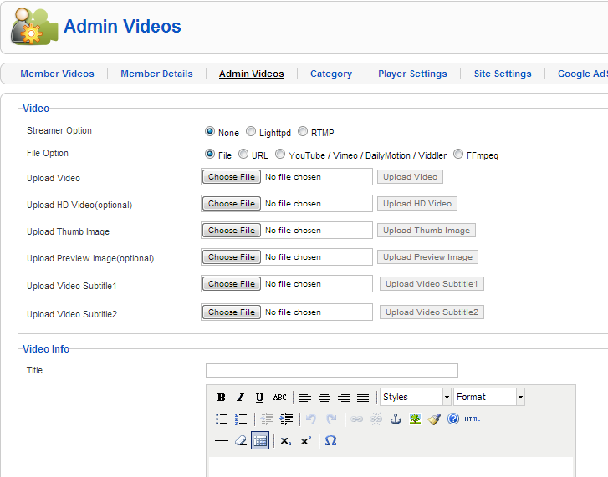Also, enable post roll and pre-roll ads for the videos.

**Adding videos through URL method**:

* Upload the videos and images through FTP to any location on your web server.

Example: you can add videos and images in the respective video and images to videos folder on your web server and provide the absolute path here.

Eg: [http://www.yourdomain.com/videos/video.mp4](%20http://www.yourdomain.com/videos/video.mp4)

<http://www.yourdomain.com/images/image.jpg>

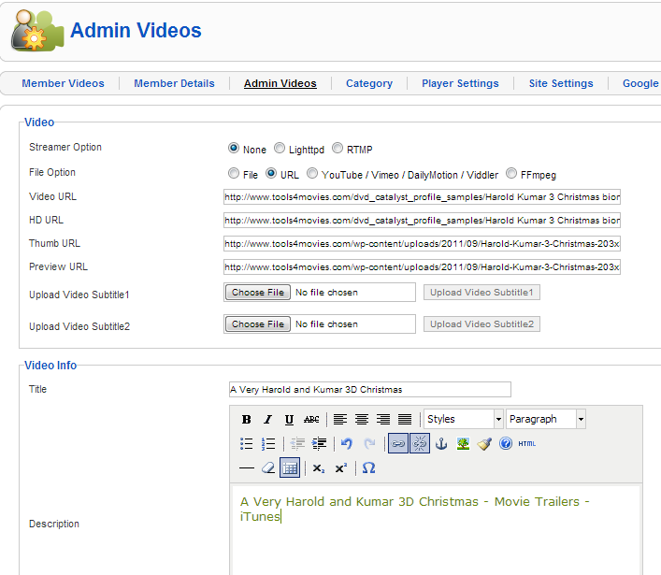

**Adding videos from YouTube /Vimeo/ Dailymotion and Viddler** :

To avoid bandwidth consumption from your web server you can also add videos to the YouTube / Vimeo / Dailymotion and Viddler and provide link here.

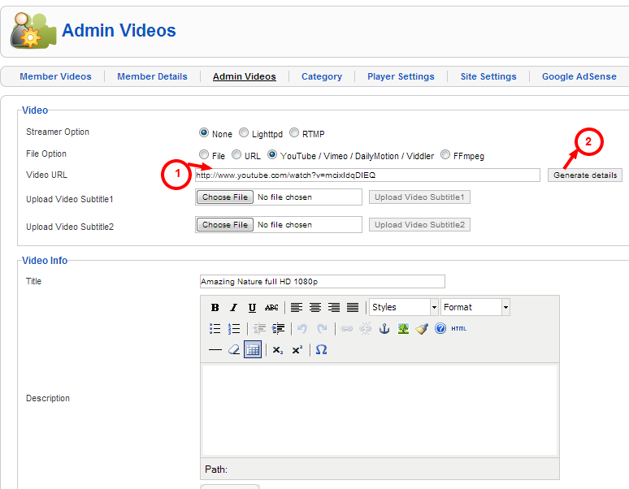

**Note:** Generate Details option will appear only when you paste YouTube link.

**Adding videos through FFMPEG**:

* Before you start uploading the videos using FFMPEG, make sure you provided the path of your FFMPEG on the "HD Video Share Settings".
* If you are not sure about the path to mention, kindly contact your hosting provider for the details.
* After you set the path to FFMPEG you can upload any HD files to convert it to lower resolution.
* The Thumbnail image and the Preview image will be create automatically.

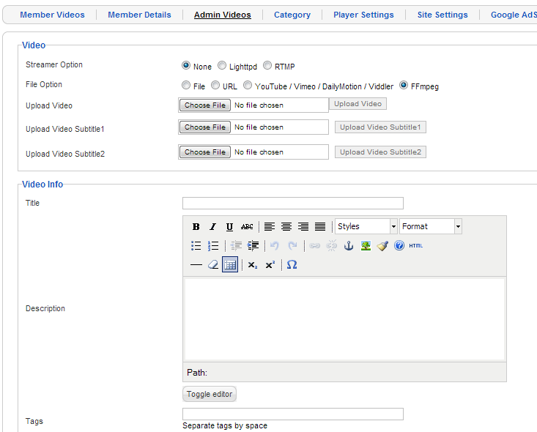

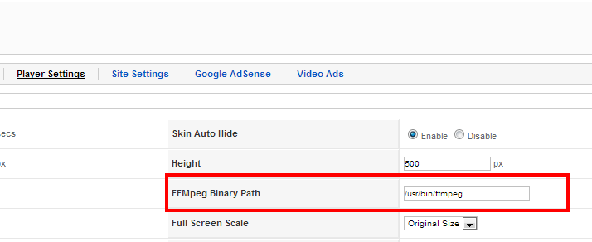

**Adding videos through Lighttpd**:

Same like adding videos through URL method. Provide the path to Non HD or HD videos or both the path (if you need). Also provide the path to the thumb and preview image.

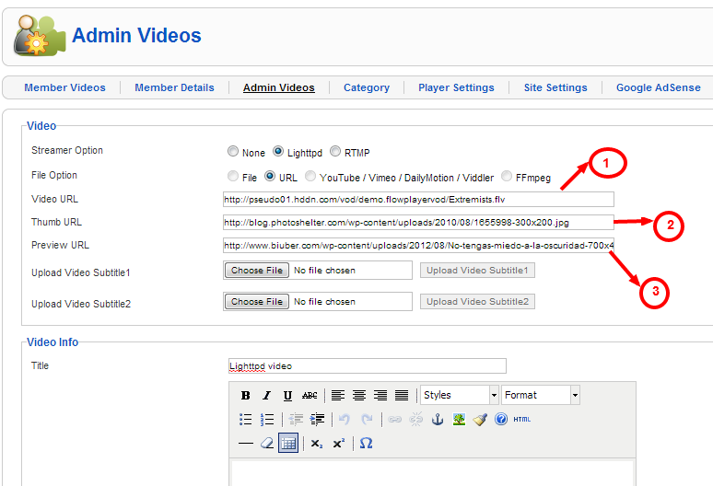

**Adding videos through RTMP**:

• Provide the Streamer path which would be rtmp://edge01.fms.dutchview.nl/botr and the video URL would be bunny.flv from the below RTMP file rtmp://edge01.fms.dutchview.nl/botr/bunny.flv

• Also there is a field for thumb and preview image URL which you can mention streamerpath = [protocol]/[servername]/[application] URL=[streamname]

1) [protocol]: You can use the following protocols: rtmp, rtmpt, rtmpe, rtmpte, rtmps

2) [servername]: this is the IP Address, or the domain name of your server. (i.e.localhost)

3) [application]: use “vod” unless you have changed the name of the folder

4) [streamname]: use the name of your video file (including the extension).

eg :

rtmp://localhost/vod/mp4:mystream.f4v

rtmpe://localhost/vod/myvideo.flv

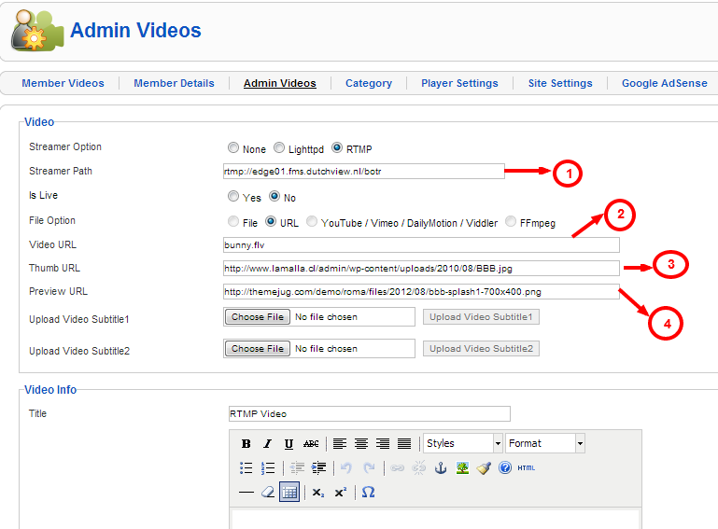

**Subtitle**

You can upload srt files to enable subtitle option for your videos. And by now you can set two different languages for that particular video. However, ensure to enter a valid language (e.g. “English” or “Russian”) in the “Subtitle 1 or 2 language” field as shown below in figure.

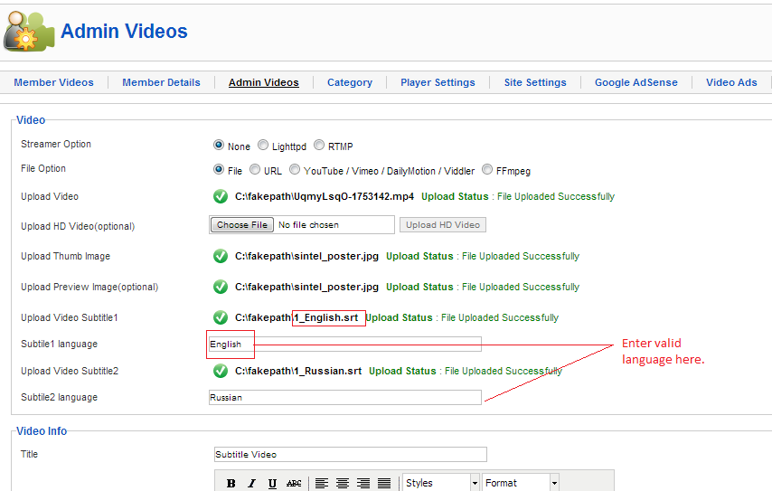

**Subtitle1 in “English” for example**

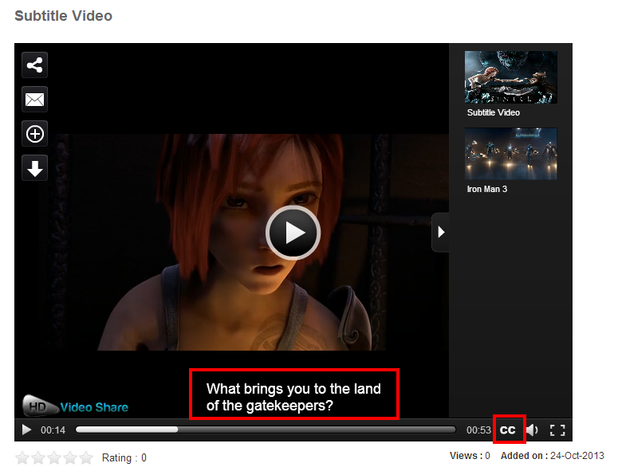

**Subtitle2 in “Russian” for example**

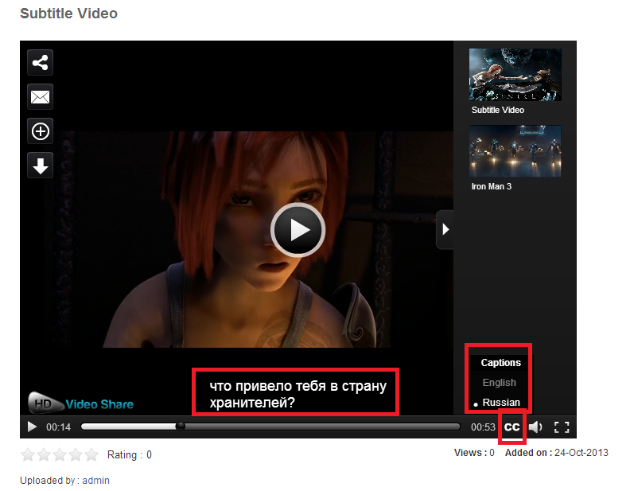

**Adding videos through Embed Code**:

This option is available only for the purchased customers. Once you entered the license key in Player Settings page, Embed code option will be enabled in Admin Videos page.

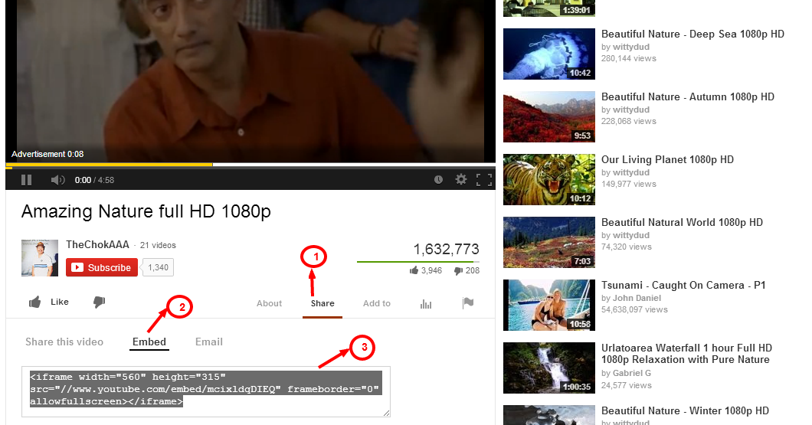

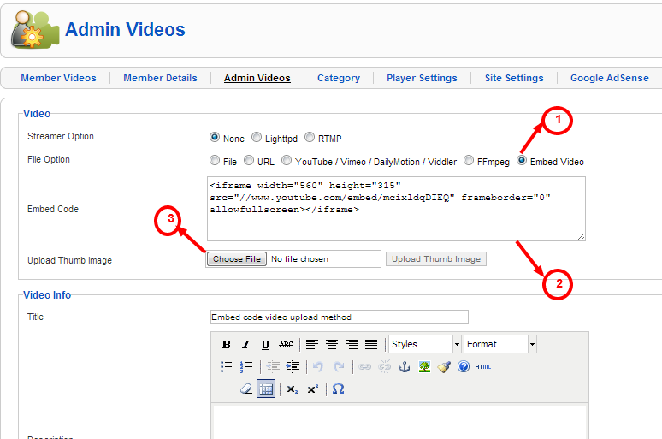

**Category**

Here, you can control the front end categories. You can create new category and modify the existing categories. Users can choose any one of these categories while adding videos.

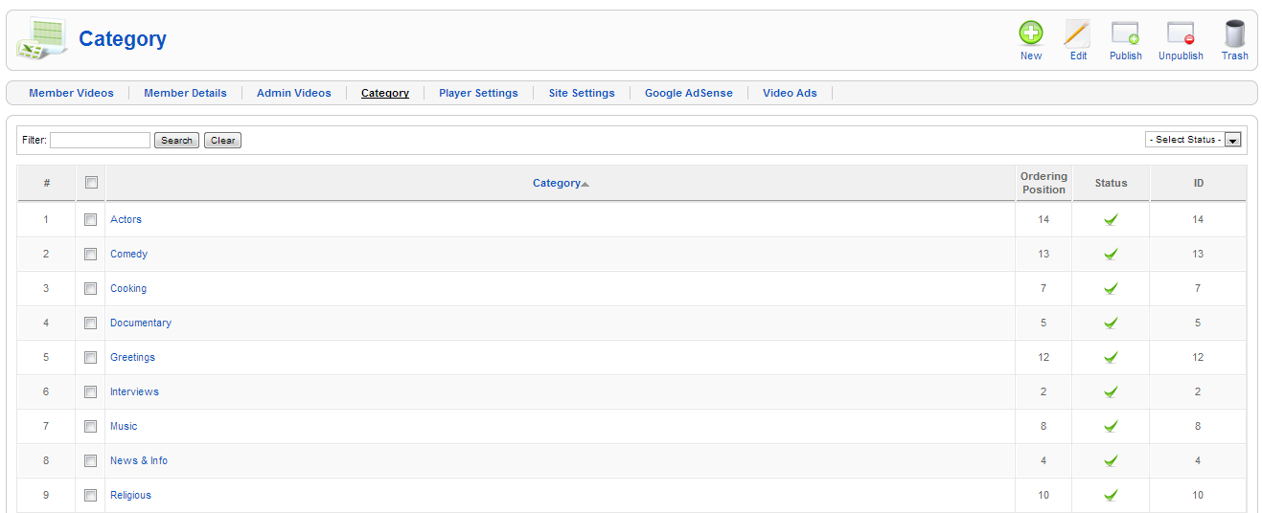

**Player Settings**

This is the global settings for HD Video Share. Modify player settings by clicking **“Edit"** button at the top right.

**Player Settings**

* **Buffer time** - You can set the buffer time of the player to save portions of a streaming Media file to local storage for a playback.
* **Volume** - You can set the default volume level when the video plays.
* **Enable Download** - You can enable or disable Download button on the player.
* **HD Default -** You can set the HD videos to play by default. Make sure you have declared HD Video path/uploaded HD videos.
* **Related Videos** - You can decide whether you want to display related videos within the player or not.
* **Playlist Open** - You can decide whether you want the related videos within the player always in open status or not.
* **Playlist Auto play -** You have two options for playlist auto play (enable/disable). If you enable the Option, it will start playing all the videos from the category. If you want to disable the option you need to select with play button for each videos.
* **Related Videos view** - You can decide whether you want to display the related videos center like YouTube or side.
* **FFMPEG Binary path -** Declare the FFMPEG path given by your hosting provider if you want to generate duration for upload videos. You can leave it as it is if you are not aware of FFMPEG.
* **Normal screen scale -** You have three choices to set. Aspect ratio which controls the player size proportionally, fit-to-screen which plays the video to the player size that Declared, Original size plays in original video size irrespective of the Player size declared.
* **Full screen scale -** This setting affects only on full screen mode.
* **Embed Visible -** It is mainly used for embedding video onto web page. You can decide whether you want to display embed code under the player in front end or not
* **Skin auto hide** - You can enable/disable skin controls to be displayed on the player.
* **Display Email -** You can disabled/enabled Email here.
* **Display Full screen** - Full screen button can be disabled from here for player control.
* **Display Progress Bar** - Progress bar can be disabled from here for player control.
* **Timer** - Timer on the player controls can be enabled/disabled.
* **Share Button** - Share button on the player can be disabled here.
* **Volume** - Volume button on the player can be disabled here.
* **Auto Play** - If it is enabled, video will start playing without users clicking the play option, else you need to select play button if option is disabled in backend.
* **Width** - You can specify the width of the player in pixels (px).
* **Height** - You can specify the width of the player in pixels (px).
* **Stage color** - Set the background color for the player in the format.(Ex: 0xdddddd)
* **Description Visible** - You can decide whether you want to display description of the video within the player or not.
* **Display Default Image** - You can decide whether you want to display default preview image (when it is not exist) for the video within the player or not.

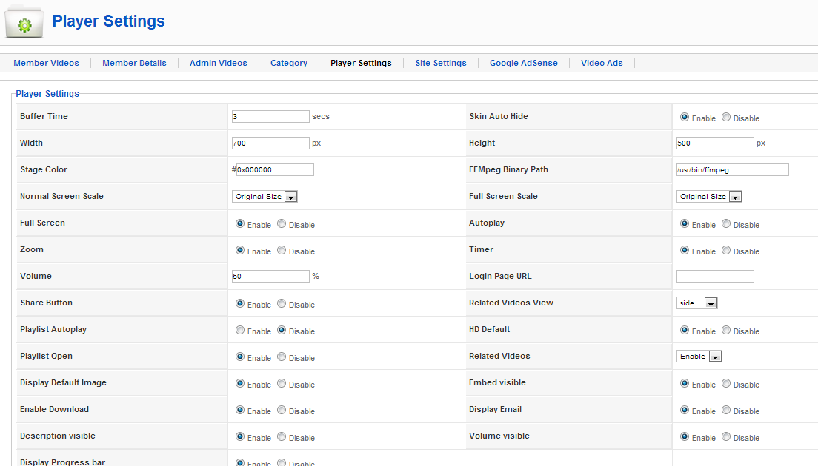

**Player Color Configuration**

* **Share Popup Header Color** - You can change the header color of the popup window when you click share button.
* **Share Popup Background Color** - You can change the background color of the popup window when you click share button.
* **Share Popup Text Color** - You can change the text color of the popup window when you click share button.
* **Send Button Color** - You can change the send button background color on the player.
* **Send Button Text Color** - You can change the send button text color on the player.
* **Player Text Color** - You can change the whole text color on the player.
* **Skin Background Color** - You can change the background color of the skin.
* **Seek Bar Color** - You can change the Seek bar color in the skin.
* **Buffer Bar Color** - You can change the buffer bar color.
* **Skin Icons Color** - You can change the all the icon colors of the skin.
* **Progress Bar Background Color** - You can change the background color of the progress bar.
* **Play Button Color** - You can change the play button color.
* **Play Button Background Color** - You can change the background color of the play button.
* **Player Buttons Color** - You can change the color of player buttons such as Share, Zoom, etc.
* **Player Buttons Background Color** - You can change the background color of player buttons such as Share, Zoom, etc.
* **Related Videos Background Color** - You can change the background color of related videos displaying inside the player. It is applicable only for “Side Related view” (Described below).
* **Related Videos Scroll Bar Color -** You can change the scroll bar color of related videos displaying inside the player. It is applicable only for “Side Related view” (Described below).
* **Related Videos Scroll Bar Background Color -** You can change the scroll bar background color of related videos displaying inside the player. It is applicable only for “Side Related view” (Described below).

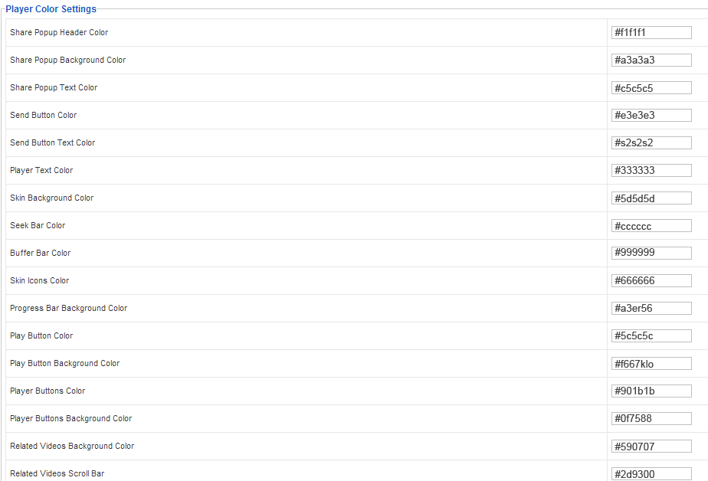

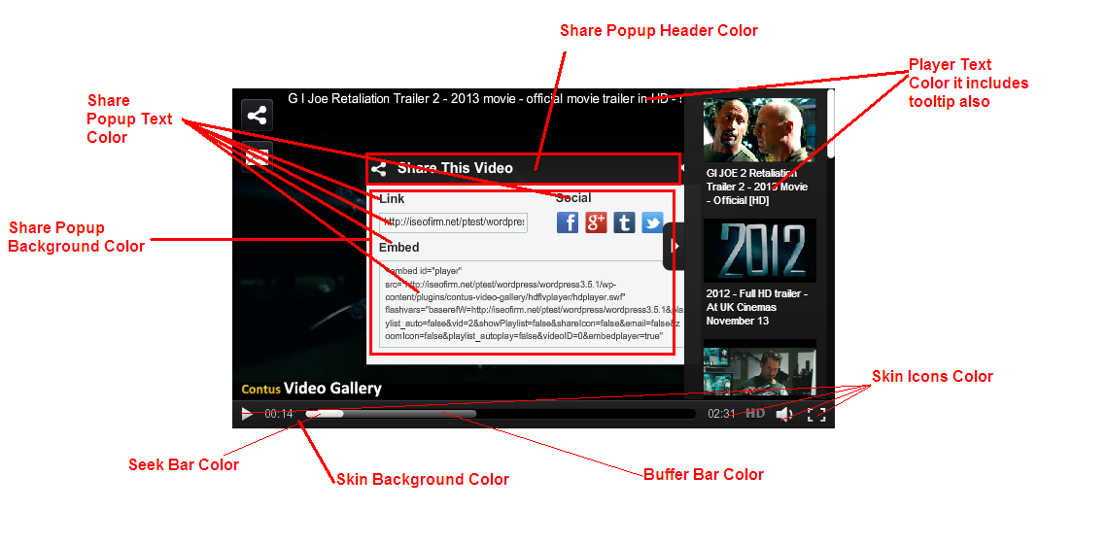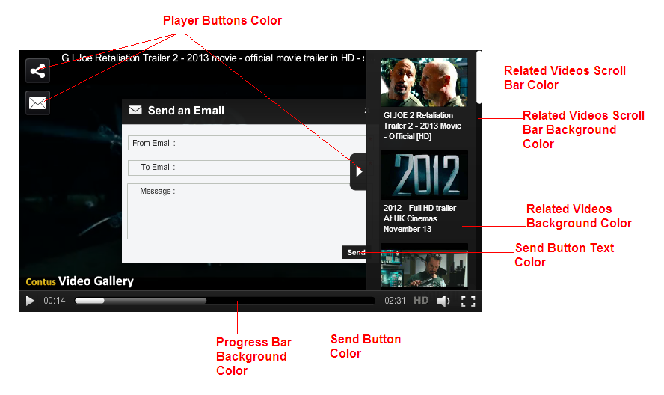

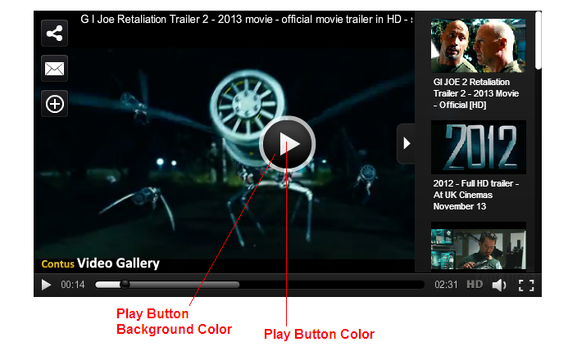

**Pre/Post- Roll Ad Settings**

* **Pre- roll ad -** You can enable/disable the pre-roll ads.
* **Post - roll ad** - You can enable/disable the post-roll ads.
* **IMA Ad** - You can enable/disable IMA ads.
* **Ad Skip** - You can decide whether you want to display skip ad while playing ads or not.
* **Ad Skip Duration** - You can enter the duration of the ads to be displayed.
* **Google Analytics** - You can enter the Google track code.

If you enabled IMA Ad then your Pre-roll and Post-roll ads will not be played in the player.

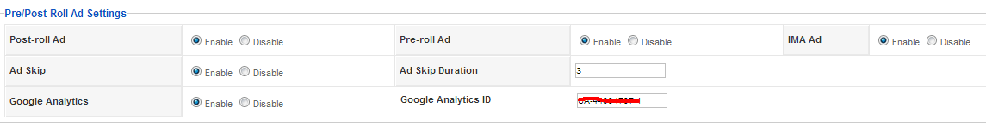

**Mid Roll Settings**

Mid-roll is a text ad which displays on the player in the middle of the video.

* **Mid- roll ad -** You can enable/disable the mid-roll ads.
* **Begin** - You can decide the time when the mid-roll start to display.
* **Rotate** - You can enable/disable mid-roll rotate option. It will display mid-roll ads one by one.
* **Mid roll Ads Random** - You can decide whether you want to enable random display of mid-roll ads.
* **Ad Interval** - You can enter the time gap between ads.

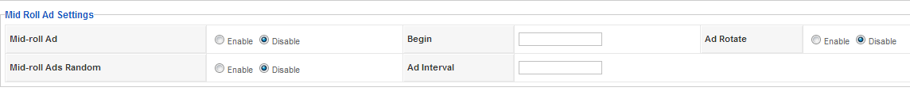

**Logo Settings**

* Demo logo will be removed only if you provide the license on the License Key field which you can obtain by purchasing it online from our Website. If you are using the free version, simply click on **Buy Now** button to purchase the license.
* Then you can upload the logo by clicking change button. Allowed extensions are png, gif, jpeg, jpg.
* Click on Right hand side **“Edit”** to change default settings.
* **Logo URL:** Enter your website URL, so that when someone click on the logo it will take them to the website that you have mentioned here.
* **Logo Position:** You can set the position of the logo. You can place the logo in top left / right and bottom left / right.

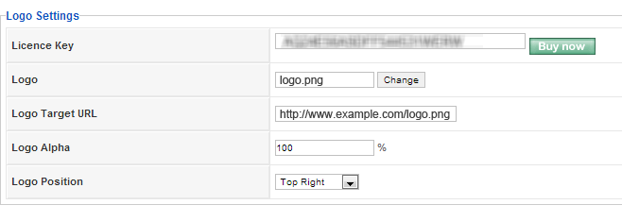

**Site Settings**

Here, you can control the number of rows and columns of the thumb images to be display in the front end for the following videos and views.

* Recent Videos
* Featured Videos
* Popular Videos
* Category View
* Related Videos
* My Videos
* Member Page View
* Side Popular Videos
* Side Featured Videos
* Side Related Videos
* Side Recent Videos

Here you have option to enable/disable for homepage popular, recent and featured with respective specified count of rows and columns and order.

Also, have yes/no option for Video Upload Option to Members, Members Login/Register, Display Ratings, Display Views and SEO URL.

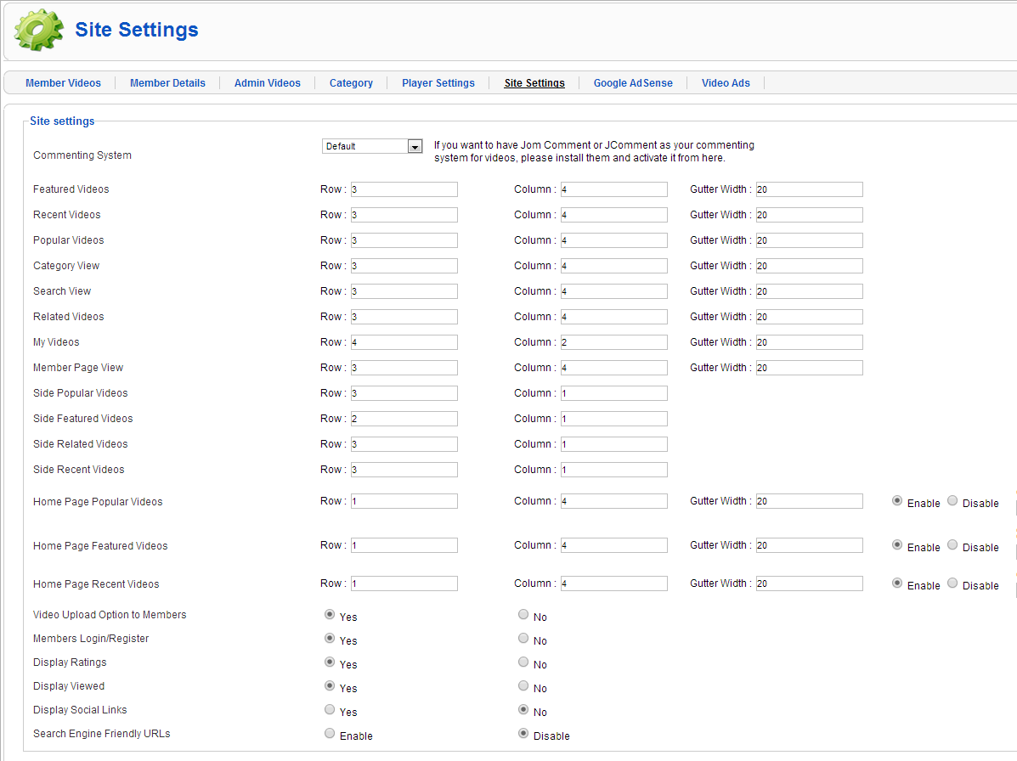

**Google Adsense**

If you have account on Google Adsense, You can configure it here. To use it, you need to enable **"Publish"** on this page to display the ads in components, modules and plugin. You can do the following configuration for Google Adsense,

* Option for showing the ads always and close it in the specified timings.
* Option to set the timings to reopen the ad again once it gets closed.

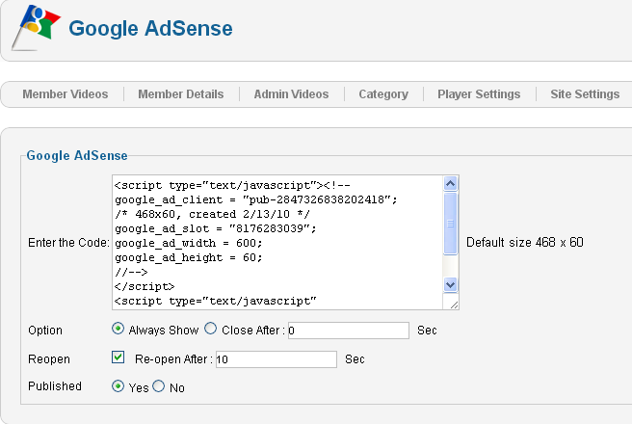

**Video Ads**

Under this tab, you can add ads for preroll/postroll or midroll. Here you can upload or provide URL videos for ads to make it to be display it as pre roll or post roll ads or mid roll ads while adding videos.

Also you can provide the target URL if you wants your user to be redirected to the particular site when clicks on the videos ads.

* Click hits URL - Here you can get the view count of how many times the ad shows on the player with the video.
* Impression URL - Here you can get the view count of how many times the user clicks on the ad and goes to the target URL.

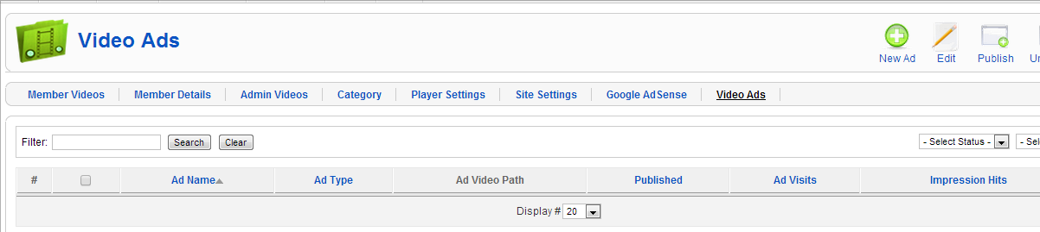

**Pre/Post Roll ads**

**Upload Method:**

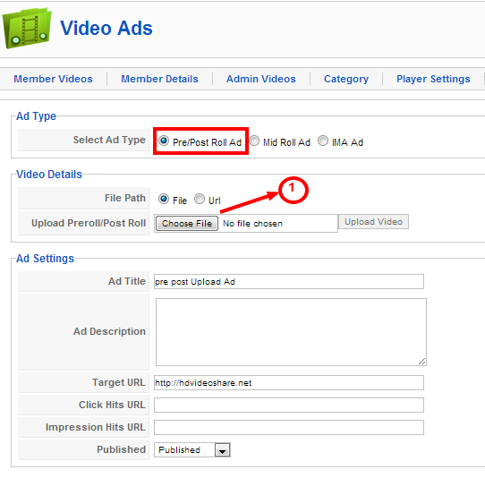

**URL Method:**

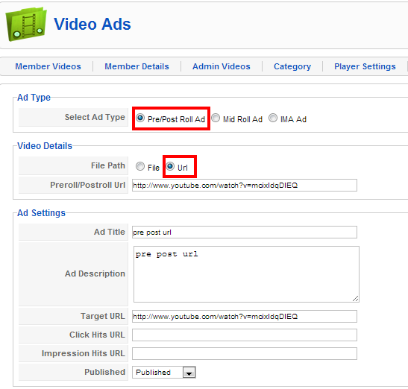

**Mid Roll ads**

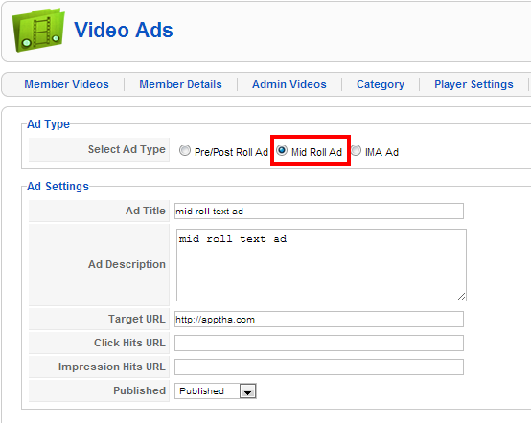

**IMA ads**

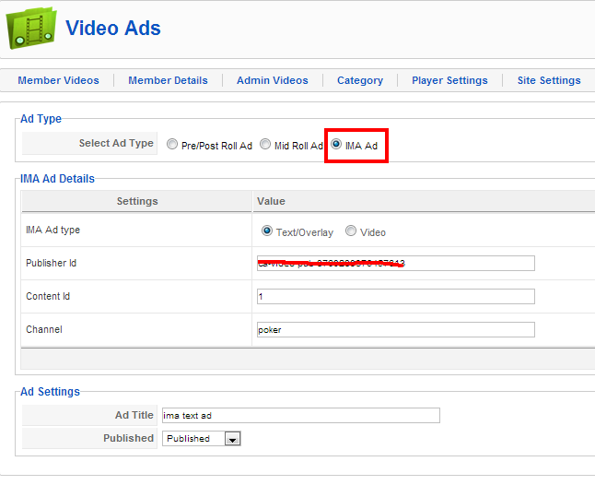

Home Page Look

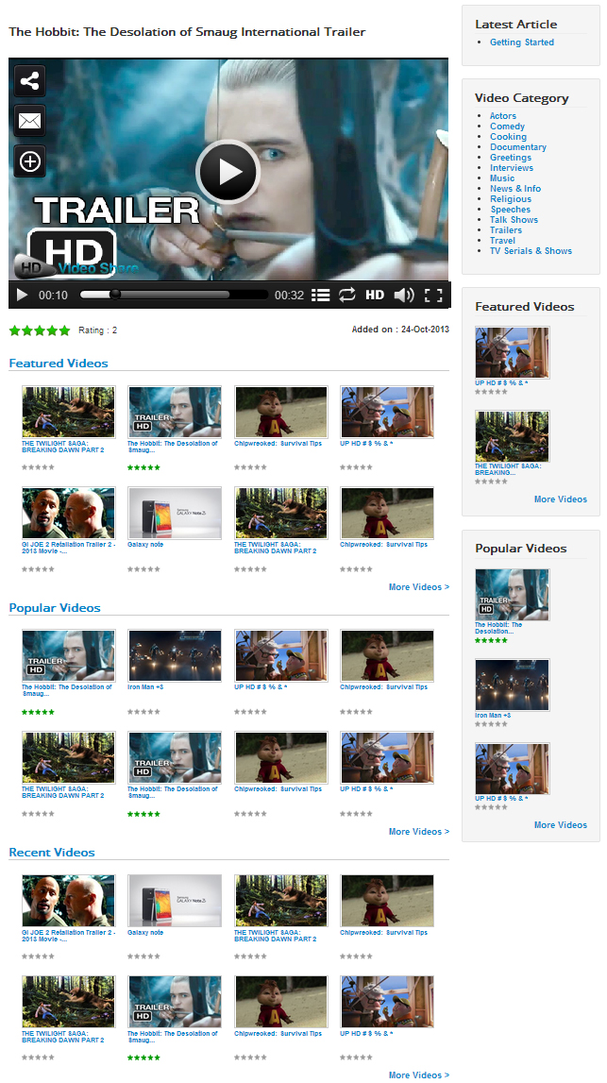This is how HD Video Share Home page will be displayed based on the Joomla template that you have selected.

**Client Side Settings**

**Login:**

Separate Signup/Login is not needed to register with HD Videos Share. Users can login using Joomla Username and Password, i.e. login into Joomla website and access HD Video Share application.

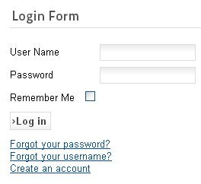

The above is the sample login form. The Login Form look and place is based on your Joomla Template and your Joomla configuration.

**Registration Form**:

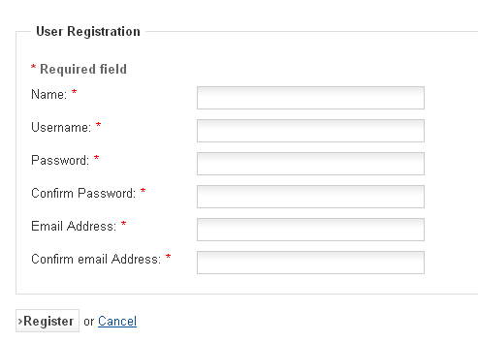

* **Username:** This is the username you will be identified by in the HD Videos Share. It must be shorter than 6 characters. It is not possible to use the name of an existing HD Video share member.
* **Password:** You must choose a password that is at least six characters long. The password will be stored Encrypted in the database of the HD Video Share, so it is impossible even for someone with access to the database to know your password.
* **Confirm password:** To exclude mistakes (for example mistyping) you have to retype your password.
* **Email address:** You need to enter a valid email address for the case that you forget your password. Once you have registered, you will be able to login with this username and password.

Once you have registered, you will get the following links “MyVideos” and “Logout”.

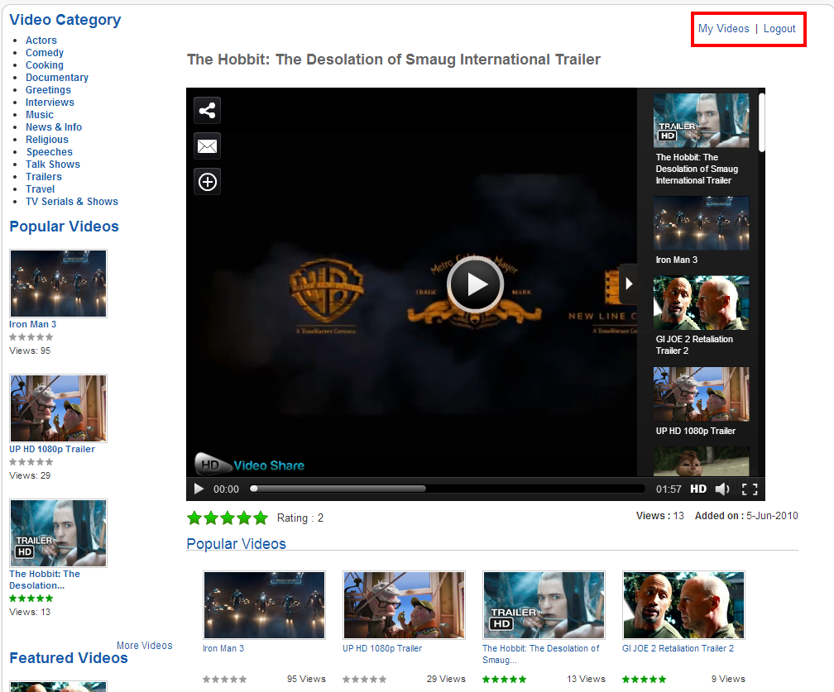

**My Videos**

My Videos tab allows you to upload videos in two ways: Upload video file or Upload via URL or Youtube and Vimeo Videos. Refer screenshots below.

**Add videos through Upload option**

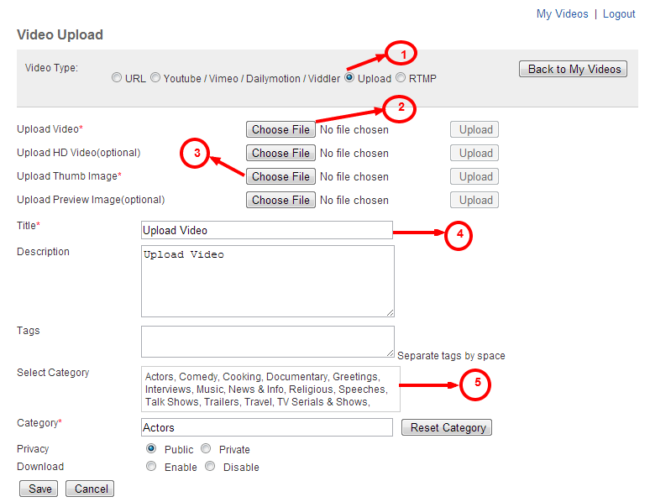

**Add your videos via URL link**

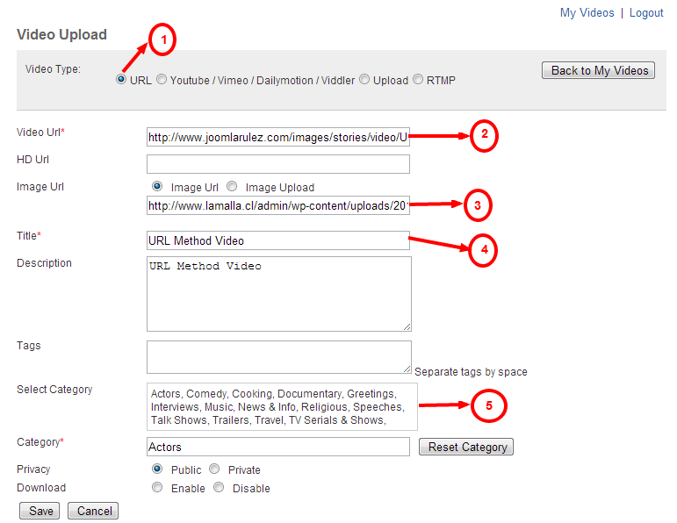

**Add Youtube, Vimeo, Viddler and Dailymotion Videos**

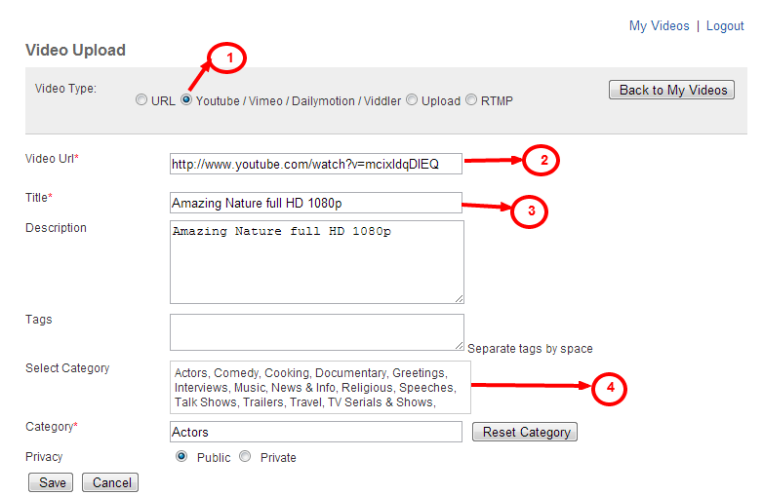

**Add RTMP Videos**

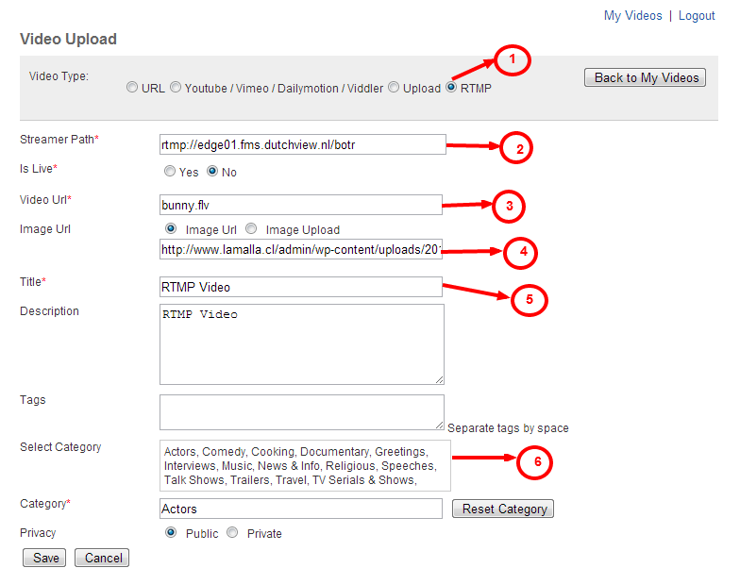

Here you can view, add and edit your videos. In this page, search module is available to search your videos in simplest manner.

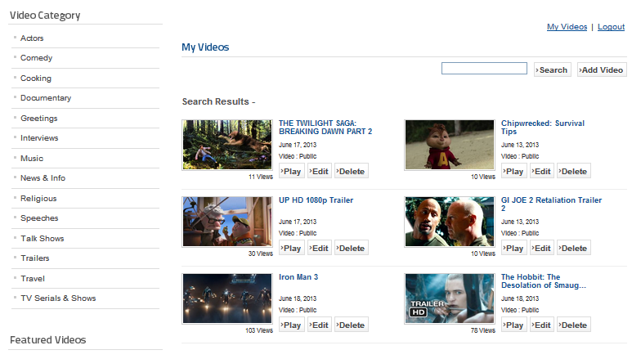

**Logout**

To logout use either Joomla sign out/ logout option or Sign out above Player. You will receive a Login module. Simply confirm by clicking on Logout.

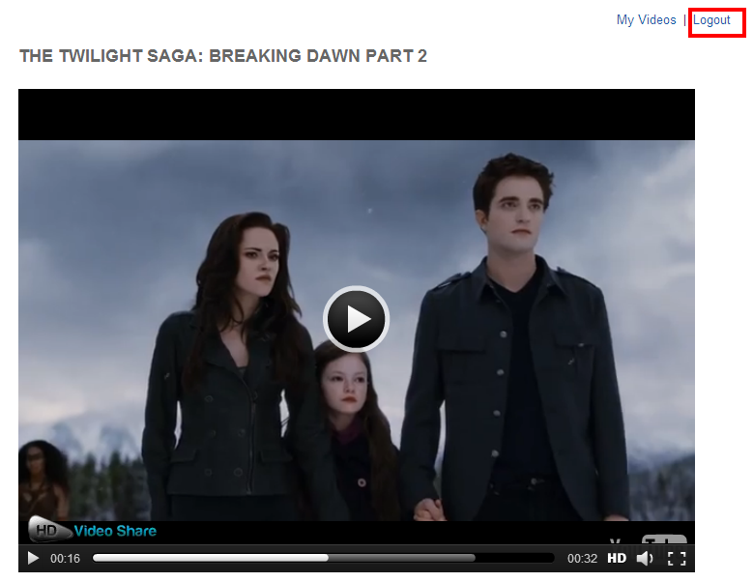

Contact us

Our support team is happy to help with any questions about using product. You may contact our support team through support forum & support tickets.

### Your question may already be answered!

Forum: [www.apptha.com/forum](http://www.apptha.com/forum)

Before you send us an email or raising tickets, take a look at Apptha.com/forum for any technical issues, common questions and more. We may have already answered your question.

### Raise tickets for your specific questions!

Tickets: [assist@apptha.com](mailto:assist@apptha.com) or [www.support.apptha.com](http://www.support.apptha.com)

Send an email to our support team to get answers to your specific questions. Our team will work to respond to your query promptly.

### The best place to discuss about additional features!

Email: [bdm@apptha.com](mailto:bdm@apptha.com)